
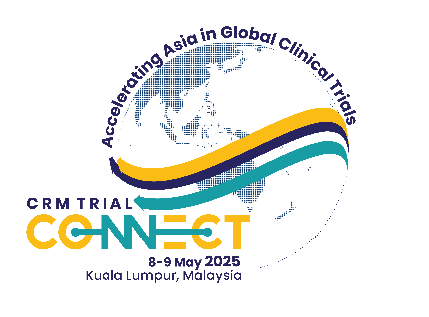


Organizers:
Oncology Workshop
6–7 May 2025, Kuala Lumpur

PROTOCOL CONCEPT SHEET
Application is via submission of the completed Protocol Concept Sheet, to brcc@clinicalresearch.my
Application Deadline: 14 April 2025

APPLICANT Name:
DESIGNATION:
oRGANISATION:
E-MAIL AdDRESS:
__________________________________________________________________________________

- What is the title of the study?

- What is the main objective of the trial?

- What is the proposed trial design?

- What is the rationale for performing this trial?

- What are the characteristics of the population under study?

- What are the planned trial interventions?

- What are the endpoints (outcome measures)?
(Can be further discussed with workshop facilitators during the workshop)

- Is the study randomized?
(Can be further discussed with workshop facilitators during the workshop)

Note: Please also consider the feasibility of the study

Example:
- Do you have access to adequate supplies of the drugs under study?
- Do you have access to the required number of patients to perform the study?

